**PyCitySchools Analysis**

**District Summary:**

The summary of the district data is as follows:



Although the district has a total budget of over 24 million dollars, the overall passing rate is less than 70 percent. Deeper analysis is required to determine root caused.

**School Summary:**

The main point of this analysis is to breakdown the district data to determine if the budget allocated per child, the type of school (District or Charter) and the size of the school have an effect on overall passing rates per school.

These points are summarized in the following table:

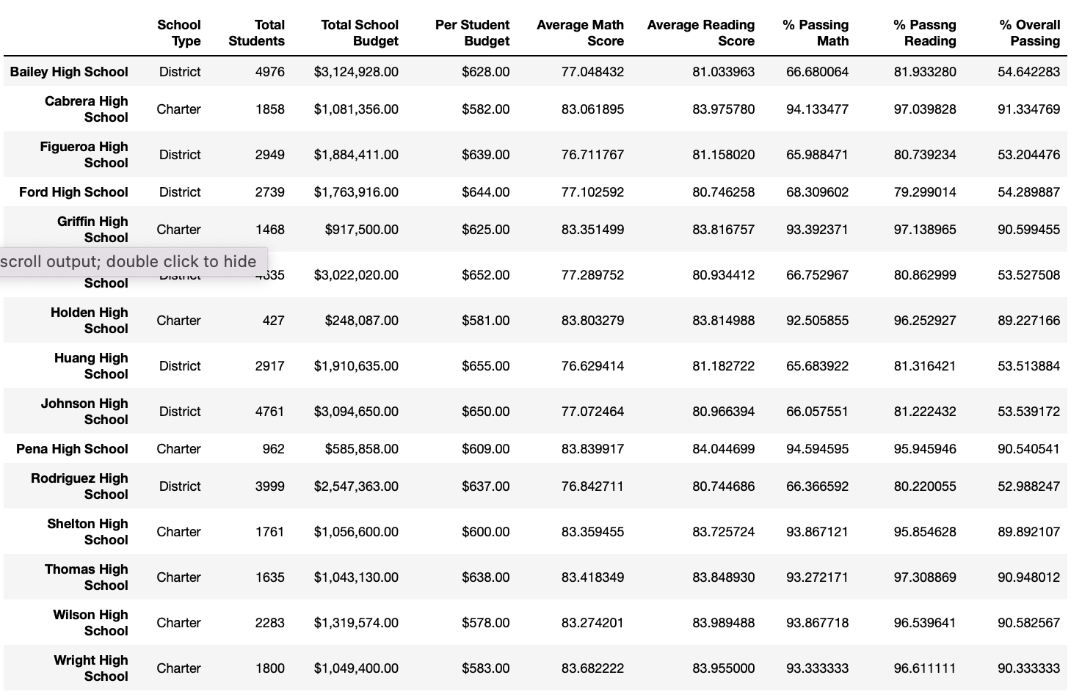

Budget Per Student:

The Budget Per Student shows that the schools with the lowest average spending rate per student have the highest overall passing rate. Also, the schools with the highest average spend rate per student have the lowest overall passing rates.

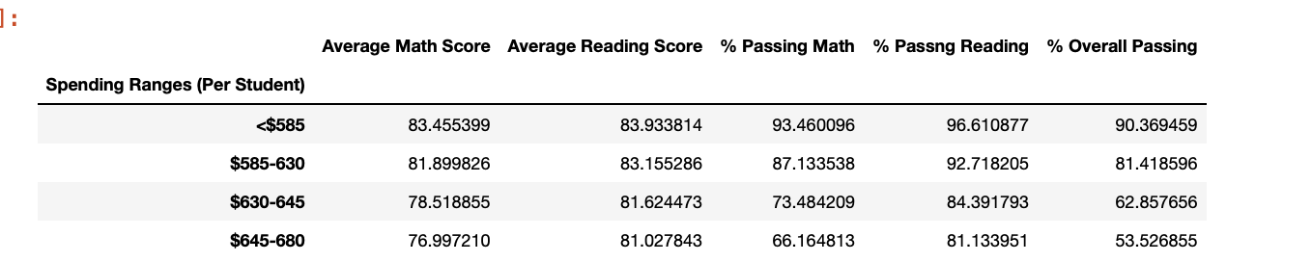

Total Size:

This data shows that with the exception of one charter school, the charter schools have a school size of medium or small. All of the district schools are classified as large. The district schools, which are classified as Large, have the lowest overall passing rates.

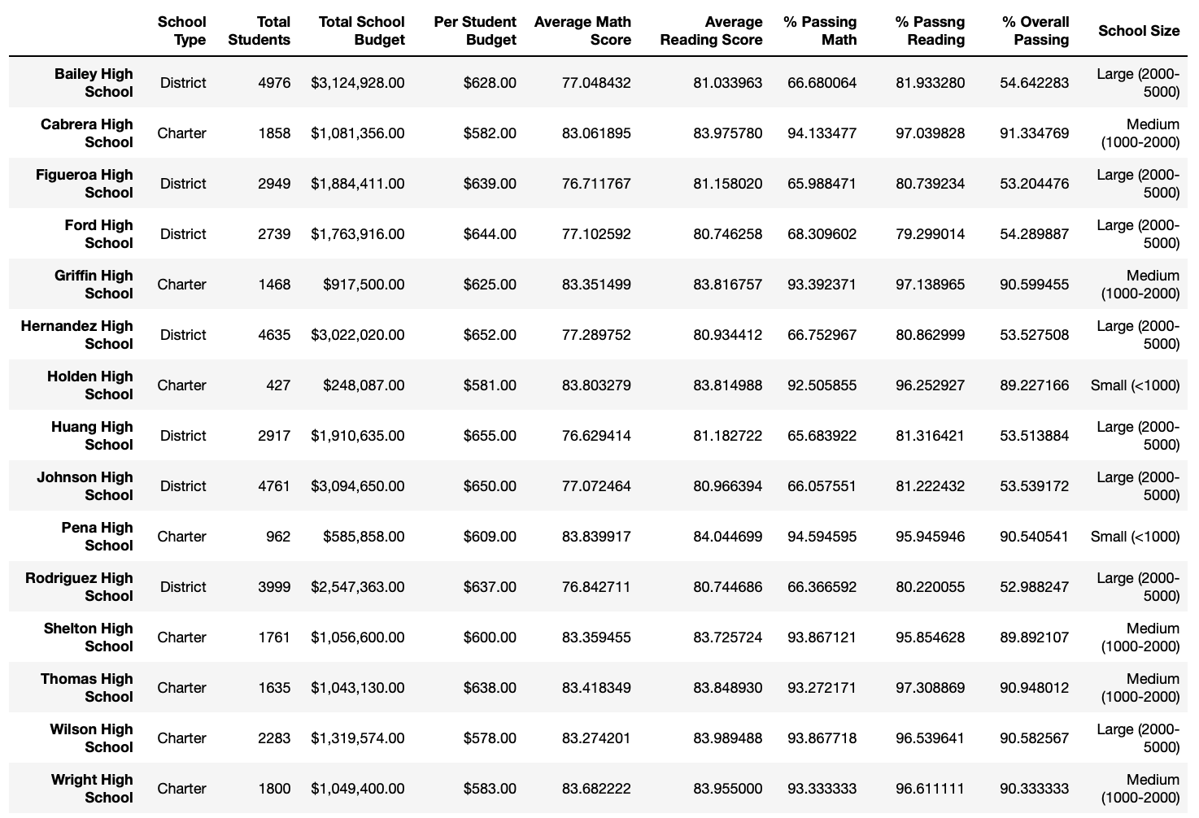

School Type:

The data shows that charter schools have a higher overall passing rate. In the previous data chart, it shows that all charter schools outperform district schools.

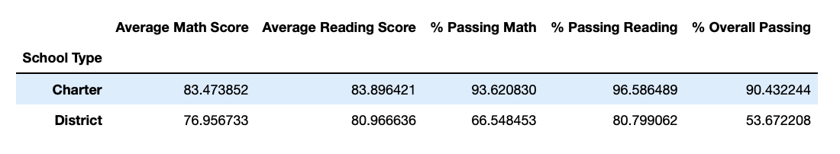

**Conclusions:**

1. Charter schools outperform district schools. One explanation for this could be that the data shows that charter schools have a smaller student population.
2. One would assume that schools that allocate a larger budget for students would have a higher overall passing rate, however the data shows just the opposite.